**Digital Twin Tag Meeting Minutes**

**Date:** January 25th, 2023

**Location:** [Microsoft Teams Link](https://teams.microsoft.com/l/meetup-join/19%3ameeting_MDhjNTg4ZDktZGFlYy00ODc0LTliYzQtMjc4MTA3ZTc3NmQ1%40thread.v2/0?context=%7b%22Tid%22%3a%22d41fdab1-7e15-4cfd-b5fa-7200e54deb6b%22%2c%22Oid%22%3a%222516780d-2412-48c9-8447-e24d7322175f%22%7d)

**Discussion Notes**

* Charter review
  + Very least getting data to cloud storage
  + Ui then pulls from cloud storage and visualizes data
  + Second term goal processing metrics and statistics
  + Zone formatting
* Python and Power BI will be used
* He will get a VPN going
* Egnyte folder will be updated
* Time stamps, tag events with a time-stamp
* Maintainability – expandable code
* Data transfers – data pipeline used for real time data Amazon timeline
* Apache Kafka – Data pipeline
* Once a minute visibility is okay but consider efficiency!
* Not anchors to symmetrical don’t want it looking at each other
* For each tag, metadata with that number – build number
  + This to tie additional info
  + Build number would be – Production
  + Number player … – Arena
  + Where is the thing right at this moment or last ping
* Identify zones: shipping …
* User interface easy way to create zoning

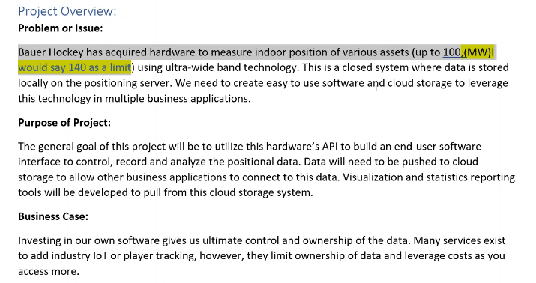

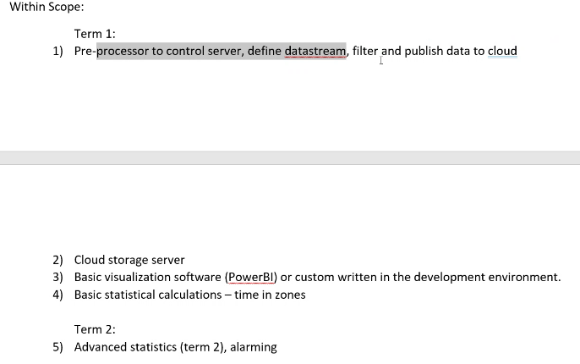

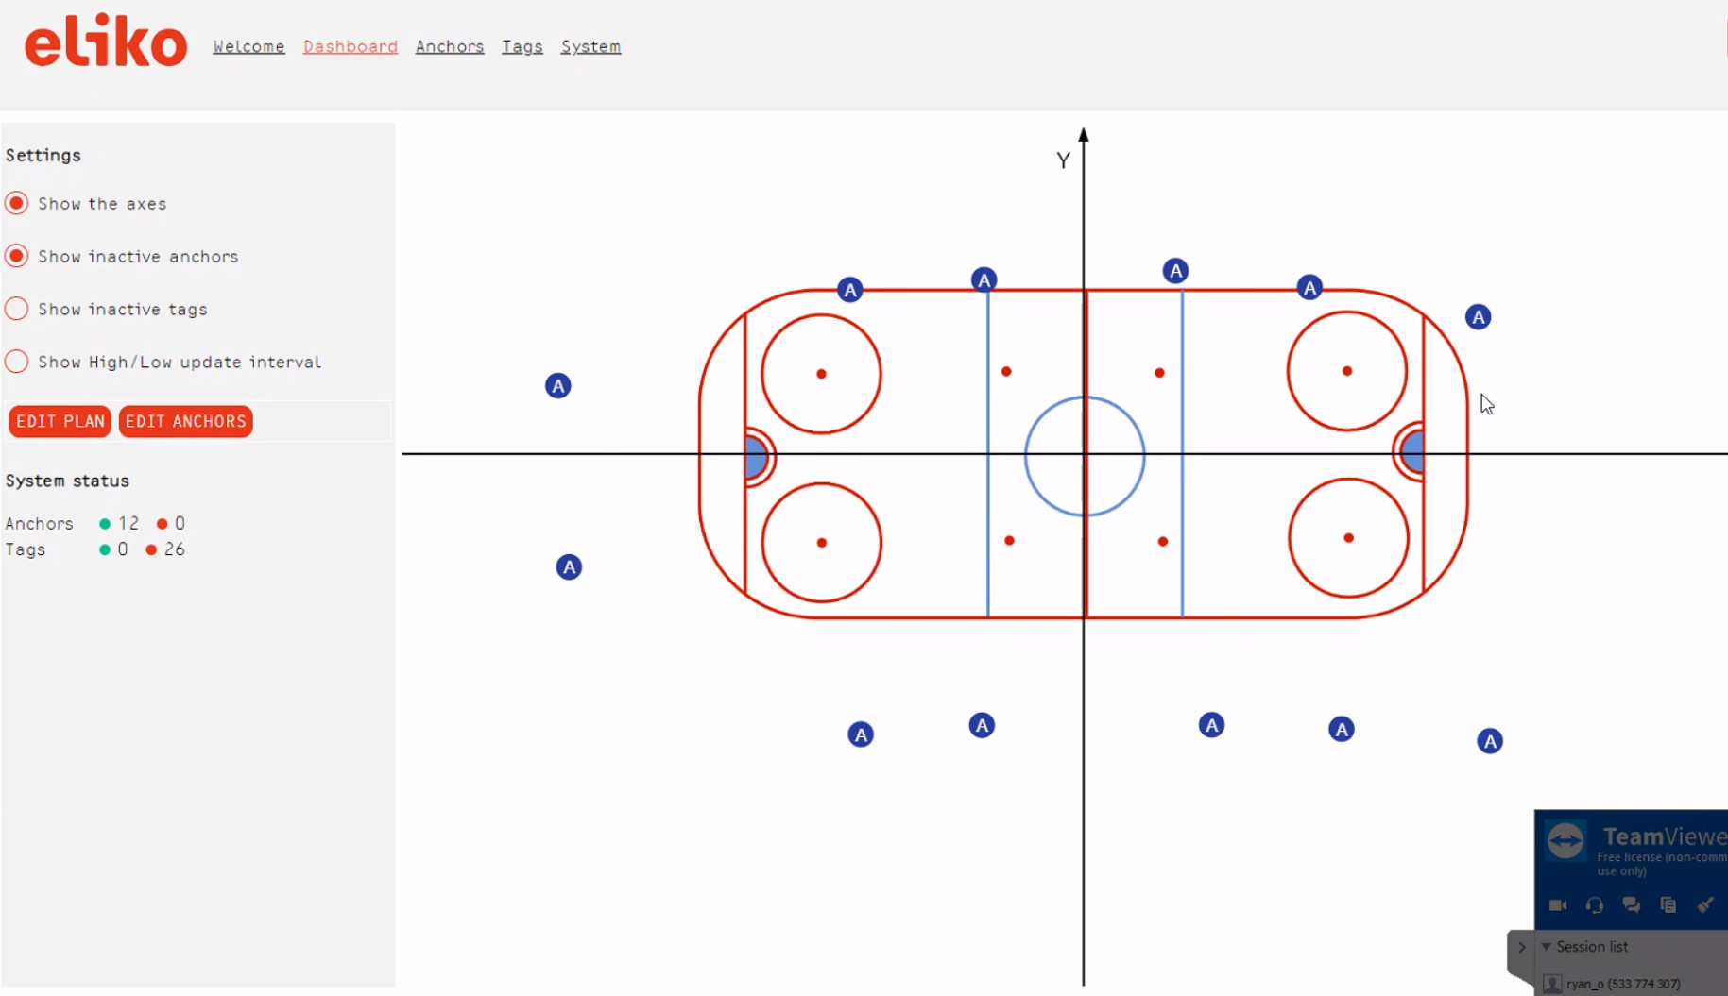

* A are the anchors
* Zone definitions or physical measurements but noise is introduced

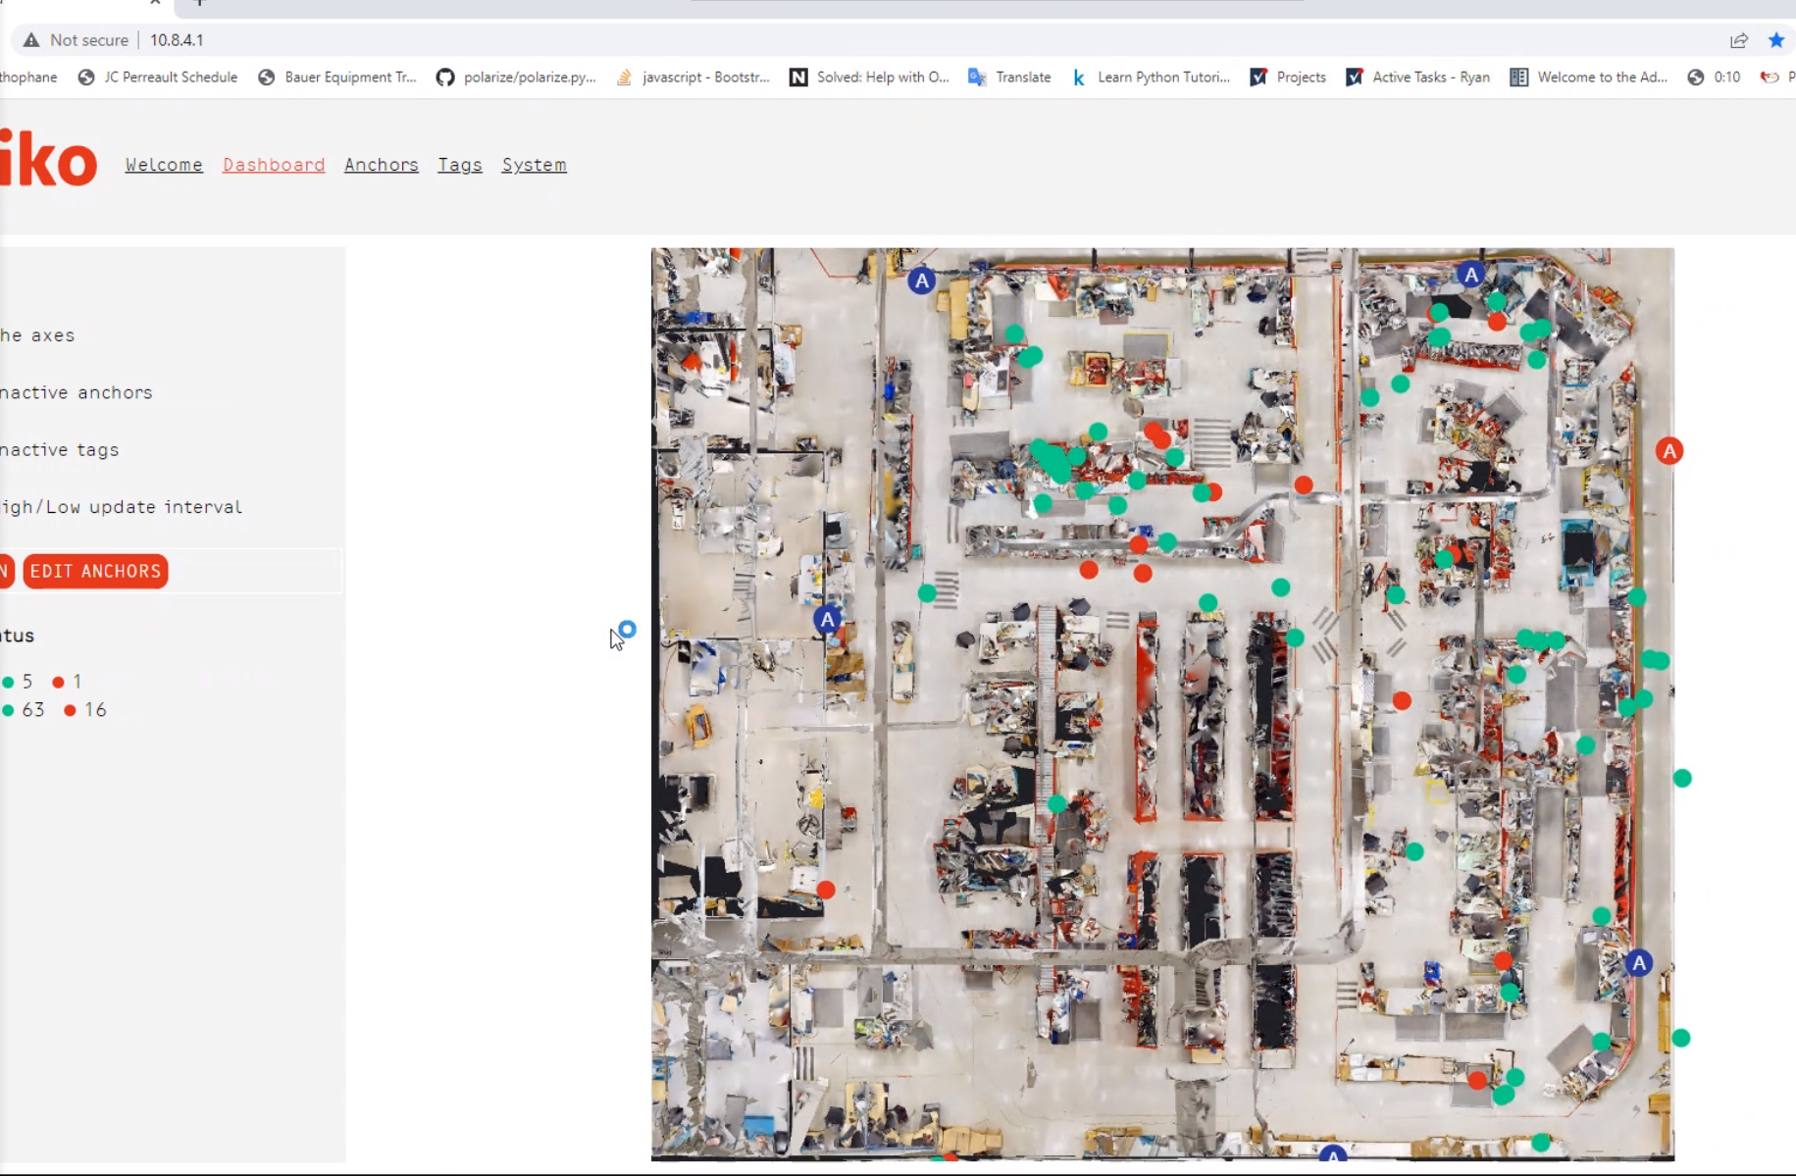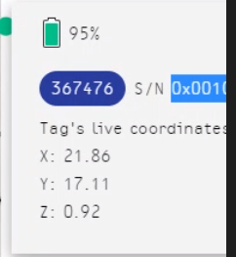

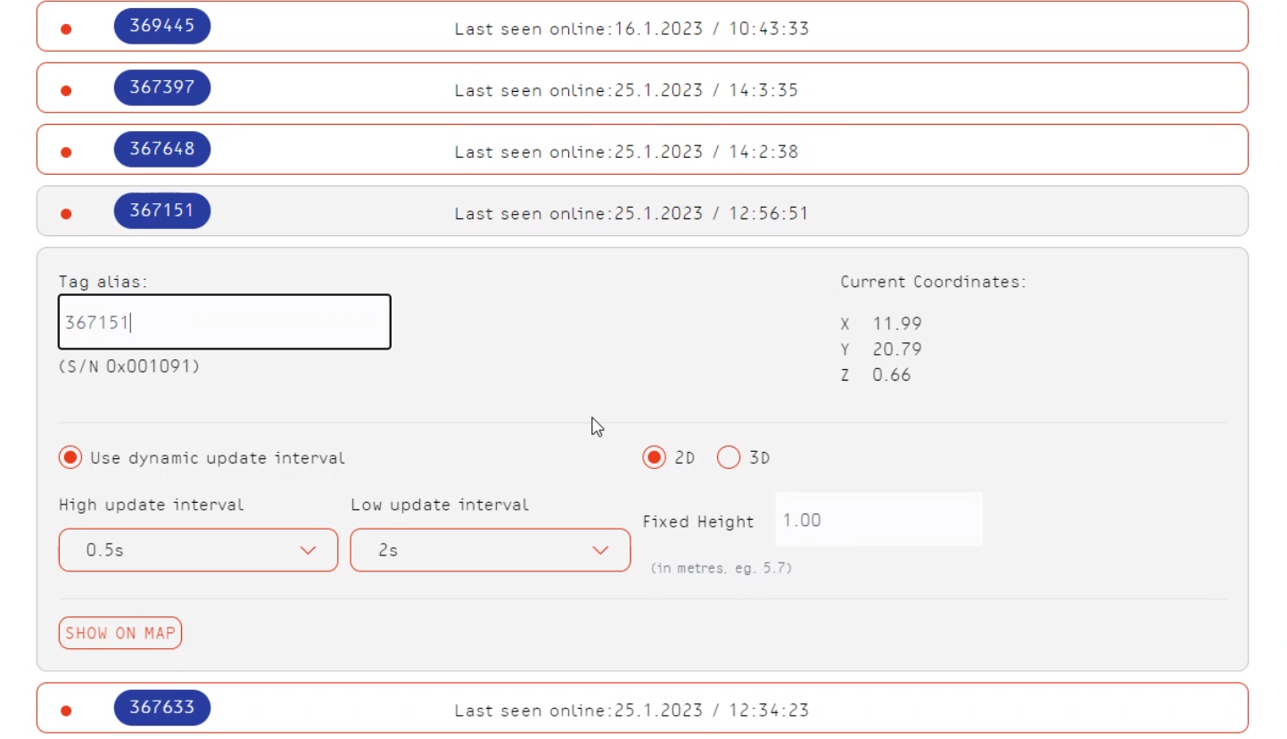

* Barcode scan – assign whip number to tag number
* Trim barcode to six numbers
* would prefer python(aggregator) and power BI(reporting tool for connecting to db) both would be used
* will add gabriels initial work, some data for us to look at
* will record basic data to internal db on the server
* will utilize streaming mode which lets us select what variables we want to exactly stream for, will be able to connect to that live stream using a port and will use python to upload that data to the web every time increment that we decide on
* camera being used is nice to have but isn't needed, whats more important to ryan is timestamps so something for that would be good to have two link the two systems
* port addresses are still the same, ip depends on the network we're connected to, would depend on the vpm , ryan will give us more info on that soon
* making it maintainable and something that can be added to in the future is part of our goal is there data that is not needed/useful now? two way communication with the tags is not active yet but could be useful in the future but for first instince wouldnt be there, just need well structured code
* data transfer would be open to using data pipelines instead of using http queries? if compatible and can convert the current tcps to that it could be something you guys can use, from manufacturing stand point one every minute is good for us, once a min is still a lot of tags so
* ryan will add sample data to the shared drive
* has arena data and production data will give both (arena 20 hertz total data could be lower cause its just for 1 or 2 players), with higher number of tags not more noise cause of the tags necessarily but cause of the environment
* how are anchors positioned in production? since not restricted by the environment not
* for production is it tracking where the item is in the prod zone, whats the main objective? want to be able to tag some meta data with each id number of each tag, serial number for each tag tells us whos it for whats the deliver date etc, want to add additional info to it, in area it is the player number, their positon , etc
* in terms of the statistics we want to pull is where is the tag now, not the history and stuff but just where was its last pin (could be 5 mins ago doesn't matter), whatever method we use if theres a few mins delay but would assume prod software would pull that info using the serial number to search it
* would love to have way to identify the different zones and maintain that

**Action Items**

* Divide first sprint into tasks, divide tasks into different sections, assign roles according to the sections created
* Determine what tools and softwares will be used for the architecture